Question 1 (2014)

This is a fragment of logic paradigm code, with child(A,B) defined as ‘B is a child

of A’.

child(jade,mary)

child(mary,wilma)

child(wilma,joan)

child(bruce,barney)

child(bruce,betty)

descendant(A,B) :− child(A,B)

descendant(A,B) :− child(A,X) , descendant(X,B)

The query descendant(mary,D) gives the result

D = wilma

D = joan

Identify a type of chaining and explain how it applies the facts and rules provided to evaluate this query.

Question 2.

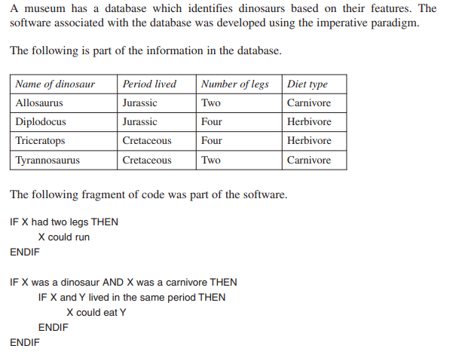

1. What are the limitations of using the imperative approach for developing this database software?
2. The database software will be rewritten using the logic paradigm.
   1. Describe the role of the inference engine in this new software.

Question 3

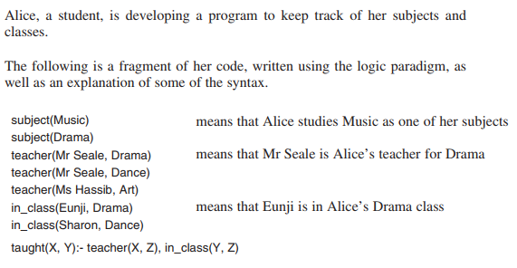

Using the facts and rules supplied, describe how taught(Mr Seale, Sharon) would be evaluated. In your answer, specify whether backward or forward chaining is used.